FSRAO

Terraform Pipelines Structure Best Practices

By



Table of Contents

Initialization Stage: 3

Planning Stage: 3

Artifact Release from Planning to Applying Stage: 4

Utilize Azure DevOps Release Pipelines: 4

Configure Pull Request Approval Triggers: 4

Applying Stage: 4

Destroying Infrastructure: 5

Security and Compliance: 5

Error Handling and Notifications: 6

Maintenance and Scalability: 6

Additional Suggestions: 7

Secure Terraform Pipeline Implementation: 8

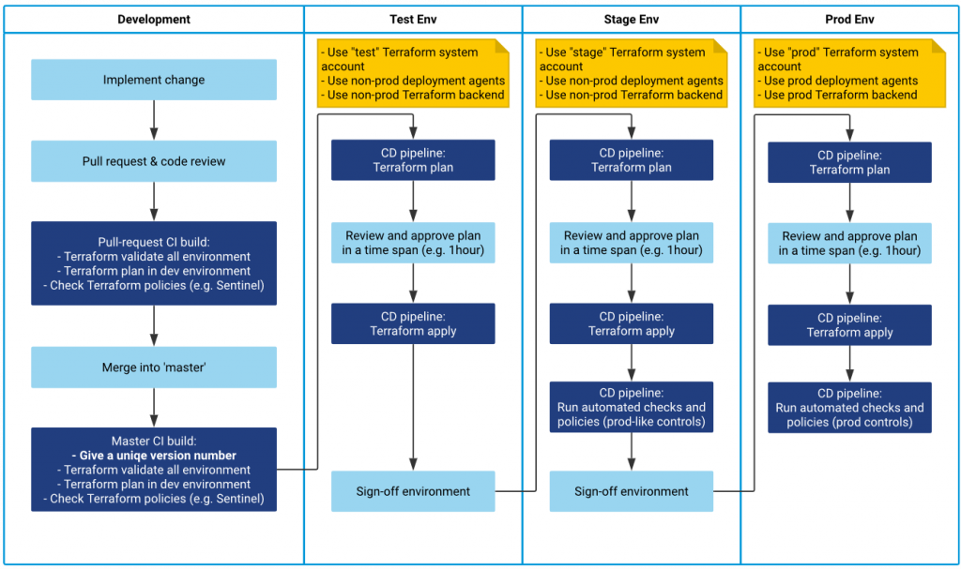**Terraform Pipelines Structure Best Practices**

# Initialization Stage:

**Use YAML Pipelines:**

* + **Reason***:* YAML pipelines offer better traceability and maintainability. They allow infrastructure configurations to be versioned alongside code, providing a clear history of changes and simplifying collaboration.

**Leverage the Command Line for Terraform Initialization:**

* + **Reason***:* Using the command line provides faster feedback during development iterations, allowing engineers to identify and address issues more quickly without waiting for a full pipeline run.

**Implement Linting:**

* + **Reason***:* Linting helps catch errors early in the process by analyzing Terraform code for syntax issues, style violations, and potential security vulnerabilities, contributing to code quality and reliability.

# Planning Stage:

**Use Terraform Partial Configuration for Local Experimentation:**

* + **Reason***:* Starting with local experimentation using partial configuration allows engineers to iterate rapidly without waiting for CI/CD cycles, facilitating a more efficient development process.

**Create a Remote State File in Azure Blob Storage:**

* + **Reason***:* Storing Terraform state remotely in Azure Blob Storage ensures a centralized and secure location for tracking infrastructure changes, improving collaboration, and reducing the risk of state file corruption.

**Avoid Default Configurations for Security Reasons:**

* + **Reason***:* Avoiding default configurations enhances security by preventing unintentional exposure of sensitive information. It ensures that configurations are explicitly defined and reviewed, reducing the risk of misconfigurations.

# Artifact Release from Planning to Applying Stage:

**Implement Artifacts to Link Planning and Applying Stages:**

* + **Reason***:* Introducing artifacts provides a seamless transition from the planning stage to the applying stage, enabling automated releases upon pull request approval. Artifacts act as deployable units, capturing the output of the planning stage for use in subsequent stages.

# Utilize Azure DevOps Release Pipelines:

* **Reason:** Leveraging Azure DevOps Release Pipelines facilitates the management of artifact releases. It allows you to define deployment stages, approvals, and triggers, providing a structured and controlled release process.

# Configure Pull Request Approval Triggers:

* **Reason:** Configuring triggers based on pull request approvals ensures that artifact releases are initiated automatically when changes are approved by managers. This streamlines the release process, reducing manual intervention.

# Applying Stage:

**Authenticate with Service Principal Credentials Stored in Azure Key Vault:**

* + **Reason:** Storing credentials in Azure Key Vault enhances security by providing a centralized and secure management solution. It follows the principle of least privilege and ensures that sensitive information is protected.

**Utilize Azure Pipelines Secrets for Secure Storage:**

* + **Reason:** Azure Pipelines secrets provide a secure way to store sensitive information, ensuring that credentials are encrypted at rest and masked during pipeline execution, minimizing the risk of exposure.

**Consider Integrating Azure Key Vault for Centralized Secret Management:**

* + **Reason:** Integrating Azure Key Vault offers advanced secret management capabilities, including versioning and rotation. It centralizes secret storage and access, simplifying security management.

# Destroying Infrastructure:

1. **Implement a Separate Stage for Destroying Infrastructure:**
   * **Reason:** Having a dedicated stage for destroying infrastructure prevents accidental destruction during routine updates. It ensures a deliberate and controlled process for decommissioning resources.

**Apply the Same Security Practices During Destruction as in the Applying Stage:**

* + **Reason:** Consistent security practices during destruction help mitigate risks associated with unauthorized access or unintended actions. It ensures that security measures remain in place throughout the entire lifecycle.

# Security and Compliance:

**Use Azure Key Vault for Managing Secrets Securely:**

* + **Reason:** Azure Key Vault provides a secure and centralized solution for managing secrets. It follows security best practices and ensures that secrets are protected with robust access controls.

**Leverage Azure Policy for Policy-as-Code Checks:**

* + **Reason:** Azure Policy enables policy-as-code checks, ensuring that infrastructure configurations comply with organizational standards and regulatory requirements. It adds an additional layer of security and compliance.

**Implement Key Vault Integration for Stronger Security and Secret Rotation:**

* + **Reason:** Integrating Azure Key Vault enhances security by enabling centralized secret management with features like rotation. It ensures that secrets are regularly updated, reducing the risk of unauthorized access.

# Error Handling and Notifications:

**Implement Proper Logging in Pipeline Scripts:**

* + **Reason:** Proper logging facilitates debugging and troubleshooting by providing detailed information about pipeline execution. It helps identify issues quickly and ensures transparency in the pipeline process.

**Configure Alerts and Notifications for Pipeline Failures or Warnings:**

* + **Reason:** Alerts and notifications provide timely awareness of pipeline failures or warnings, allowing teams to respond promptly. This improves incident response times and minimizes downtime.

**Utilize Azure DevOps Built-in Notifications and Logging Features:**

* + **Reason:** Leveraging built-in features in Azure DevOps enhances visibility into pipeline execution. It ensures that teams are informed about pipeline events and can access relevant information for analysis.

# Maintenance and Scalability:

**Stay Up-to-Date with the Latest Terraform Version for Incremental Changes:**

* + **Reason:** Keeping Terraform up-to-date ensures access to the latest features, bug fixes, and security updates. Incremental changes make it easier to adapt to new capabilities without significant disruptions.

**Consider Modularizing Terraform Configurations for Scalability:**

* + **Reason:** Modularizing Terraform configurations promotes scalability by allowing components to be reused across projects. It enhances maintainability and reduces duplication of code.

**Implement Version Control for Terraform Configurations:**

* + **Reason:** Version control provides a history of changes to Terraform configurations, enabling collaboration, rollback capabilities, and auditability. It ensures a systematic approach to managing infrastructure as code.

**Regularly Review and Update Pipeline Configurations to Align with Best Practices:**

* + **Reason:** Regular reviews and updates to pipeline configurations ensure alignment with evolving best practices, security standards, and organizational requirements. It fosters continuous improvement and adaptation.

# Additional Suggestions:

**Documentation:**

* + **Reason:** Detailed documentation enhances understanding, onboarding, and collaboration. Inline comments in YAML Pipelines provide additional clarity and context, making the codebase more accessible.

**Testing:**

* + **Reason:** Automated testing ensures the reliability of Terraform configurations. Whether using Terraform's testing tools or custom tests, it helps catch regressions and ensures the stability of infrastructure changes.

**Role-Based Access Control (RBAC):**

* + **Reason:** Following the principle of least privilege through custom RBAC roles ensures that Terraform has only the necessary permissions. Regular reviews of RBAC settings help maintain a secure access control environment.

**Auditability:**

* + **Reason:** Enabling audit logging in Azure DevOps and implementing Git workflows with protected branches enhances traceability and accountability. It meets compliance requirements and supports auditing processes.

**Continuous Improvement:**

* + **Reason:** Regular reviews of pipeline performance and efficiency foster a culture of continuous improvement. Emphasizing ongoing enhancement ensures that the DevOps process remains adaptive and efficient over time.

# Secure Terraform Pipeline Implementation:

**Protect the "Master" Branch:**

* **Reason:** Configuring Git to prevent direct pushes to the "master" branch and enforcing changes through pull requests ensures a controlled and auditable release process. This adds an extra layer of security and accountability.

**Build a Multi-Stage Pipeline:**

* **Reason:** Implementing a multi-stage pipeline allows visualization of Terraform configuration versions as they are promoted across different environments. This enhances transparency and ensures a clear promotion path.

**Rely on Versions Rather Than Branches:**

* **Reason:** Prioritizing version-based promotions over branches ensures that immutable snapshots of Terraform configurations are promoted. This minimizes the risk of deploying untested or unauthorized changes.

**Have a Terraform "Build" Step:**

* **Reason:** Including a Terraform "build" step, even if it involves validating against configurations of all environments, aids in catching obvious errors early. It contributes to setting version numbers or tags on the master branch version.

**Have a Manual Approval Step for Terraform Plan:**

* **Reason:** Introducing a manual approval step for Terraform plans ensures that changes are reviewed and approved by a human before application. This adds an extra layer of validation to the deployment process.

**Ensure Only One Pending Plan per Environment:**

* **Reason:** Preventing concurrent plans pending on a single environment ensures that the deployment process remains controlled and avoids conflicts between different Terraform changes.

**Protect Access to Separate System Accounts per Environment:**

* **Reason:** Securing access to separate system accounts for different environments ensures that credentials and keys are managed securely. It prevents unauthorized access to sensitive information.

**Protect Access to Separate Agent Pools per Environment:**

* **Reason:** Isolating agent pools for non-prod and prod deployments ensures that network access is limited appropriately. It enhances security by preventing non-prod build agents from accessing the production runtime environment.

**Have a Rollback Plan:**

* **Reason:** Developing a rollback plan allows for the quick and controlled reversal of changes in case of issues. This ensures a rapid response to unexpected situations without compromising stability.

**Control User Permissions to Environments:**

* **Reason:** Managing user permissions to environments ensures that only authorized personnel can deploy changes to specific environments. Implementing a four-eye-check for production releases adds an extra layer of approval.

**Have Just-in-Time Access Control for Terraform:**

* **Reason:** Implementing just-in-time access control ensures that the production Terraform system account is available only during planned releases. It aligns with the principle of least privilege and enhances security.

**Run Tests as Part of the Pipeline:**

* **Reason:** Incorporating tests, including compliance and security checks, as part of the pipeline ensures the reliability and compliance of Terraform configurations. It provides quick feedback on any deviations from non-functional requirements and policies.